JUSTIN V GEORGE

HOW I STARTED WITH KUBERNETES  
---------------------------------------------------------------------

DISCLAIMER : I Do not own any intellectual rights to any of the contents nor do I plan to use this document for distribution/redistribution of any information written below. These have been gathered from different sources(as cited below) and has been prepared by me for self-learning purposes and to prepare a documentation for future references (something I can come back to-to refresh the topics).

CONTENT SOURCES:

Official documentation:

<https://kubernetes.io/docs/concepts/es>

starter/ hands-on tutorial landing page:

<https://kubernetes.io/docs/tutorials/>

Tutorial: <https://kubernetes.io/docs/tutorials/kubernetes-basics/>

Course (Recommended in Official Kubernetes Documentation/tutorial) :

(Literature content – no hands on – paid certification(189$) (might do after getting a good job?)

–course content viewable )

<https://www.edx.org/learn/kubernetes/the-linux-foundation-introduction-to-kubernetes>

other resources---

Hands-on guide:

<https://collabnix.github.io/kubelabs/>

Free Code Camp beginners tutorial :

<https://www.youtube.com/watch?v=d6WC5n9G_sM>

Cheat Sheet:

<https://collabnix.github.io/kubelabs/Cheat%20Sheets/Kubernetes%20Cheat%20Sheet.md>

minikube commands ---🡪 [Minikube command line reference](https://minikube.sigs.k8s.io/docs/commands/).

after getting a job? Or when getting A LOT of Free time: (-_-)

the [*Kubernetes The Hard Way*](https://github.com/kelseyhightower/kubernetes-the-hard-way) GitHub project by [Kelsey Hightower](https://twitter.com/kelseyhightower) is an extremely helpful installation guide and resource.

**MONOLITH**

Moving an application to the cloud should be as easy as walking on the beach and collecting pebbles in a bucket and easily carrying them wherever needed. A 1000-ton boulder, on the other hand, is not easy to carry at all. This boulder represents the monolith application - sedimented layers of features and redundant logic translated into thousands of lines of code, written in a single, not so modern programming language, based on outdated software architecture patterns and principles.

A **monolith** has a rather expensive taste in hardware. Being a large, single piece of software which continuously grows, it has to run on a single system which has to satisfy its compute, memory, storage, and networking requirements. The hardware of such capacity is not only complex and extremely pricey, but at times challenging to procure.

Since the entire monolith application runs as a single process, the scaling of individual features of the monolith is almost impossible. It internally supports a hardcoded number of connections and operations. However, scaling the entire application can be achieved by manually deploying a new instance of the monolith on another server, typically behind a load balancing appliance - another pricey solution.

During upgrades, patches or migrations of the monolith application downtime is inevitable and maintenance windows have to be planned well in advance as disruptions in service are expected to impact clients.

**MICROSERVICES**

**Microservices** can be deployed individually on separate servers provisioned with fewer resources - only what is required by each service and the host system itself, helping to lower compute resource expenses.

Microservices-based architecture is aligned with Event-driven Architecture and Service-Oriented Architecture (SOA) principles, where complex applications are composed of small independent processes which communicate with each other through Application Programming Interfaces (APIs) over a network. APIs allow access by other internal services of the same application or external, third-party services and applications.

Although the distributed nature of microservices adds complexity to the architecture, one of the greatest benefits of microservices is scalability. With the overall application becoming modular, each microservice can be scaled individually, either manually or automated through demand-based autoscaling.

Seamless upgrades and patching processes are other benefits of microservices architecture. There is virtually no downtime and no service disruption to clients because upgrades are rolled out seamlessly - one service at a time, rather than having to recompile, rebuild and restart an entire monolithic application. As a result, businesses are able to develop and roll-out new features and updates a lot faster, in an agile approach, having separate teams focusing on separate features, thus being more productive and cost-effective.

REFACTORING

Some have tried to run monoliths as microservices, and as one would expect, it did not work very well. The lessons learned were that a monolithic size multi-process application cannot run as a microservice and that other options had to be explored. The next natural step in the path of the monolith to microservices transition was refactoring. However, migrating a decades-old application to the cloud through refactoring poses serious challenges and the enterprise faces the refactoring approach dilemma: a "Big-bang" approach or an incremental refactoring.

"Big-bang" approach focuses all efforts with the refactoring of the monolith, postponing the development and implementation of any new features - essentially delaying progress and possibly, in the process, even breaking the core of the business, the monolith.

An incremental refactoring approach guarantees that new features are developed and implemented as modern microservices which are able to communicate with the monolith through APIs, without appending to the monolith's code. In the meantime, features are refactored out of the monolith which slowly fades away while all, or most its functionality is modernized into microservices. This incremental approach offers a gradual transition from a legacy monolith to modern microservices architecture and allows for phased migration of application features into the cloud.

Once an enterprise chooses the refactoring path, ->other considerations in the process include which business components to separate from the monolith to become distributed microservices, how to decouple the databases from the application to separate data complexity from application logic, and how to test the new microservices and their dependencies, are just a few of the decisions an enterprise is faced with during refactoring.

The refactoring phase slowly transforms the monolith into a cloud-native application which takes full advantage of cloud features, by coding in new programming languages and applying modern architectural patterns. Through refactoring, a legacy monolith application receives a second chance at life - to live on as a modular system adapted to fully integrate with today's fast-paced cloud automation tools and services.

**CHALLENGES**

When considering a legacy Mainframe based system, written in older programming languages - Cobol or Assembler, it may be more economical to just re-build it from the ground up as a cloud-native application. A poorly designed legacy application should be re-designed and re-built from scratch following modern architectural patterns for microservices and even containers. Applications tightly coupled with data stores are also poor candidates for refactoring.

Once the monolith survived the refactoring phase, the next challenge is to design mechanisms or find suitable tools to keep alive all the decoupled modules to ensure application resiliency as a whole.

Choosing runtimes may be another challenge. If deploying many modules on a single physical or virtual server, chances are that different libraries and runtime environments may conflict with one another, causing errors and failures.

Eventually a solution emerged to tackle these refactoring challenges. Application containers came along providing encapsulated lightweight runtime environments for application modules. Containers promised consistent software environments for developers, testers, all the way from Development to Production. Wide support of containers ensured application portability from physical bare-metal to Virtual Machines, but this time with multiple applications deployed on the very same server, each running in their own execution environments isolated from one another, thus avoiding conflicts, errors, and failures. Other features of containerized application environments are higher server utilization, individual module scalability, flexibility, interoperability and easy integration with automation tools.

Kubernetes success stories

AppDirect, box, Crowdfire, golfNow, Pinterest

**CONTAINER ORCHESTRATION**

Container images allow us to confine the application code, its runtime, and all of its dependencies in a pre-defined format. The container runtimes like **runC**, **containerd**, or **cri-o** can use pre-packaged images as a source to create and run one or more containers. These runtimes are capable of running containers on a single host, however, in practice, we would like to have a fault-tolerant and scalable solution, achieved by building a single **controller**/**management unit**, a collection of multiple hosts connected together. This controller/management unitis generally referred to as a **container orchestrator**.

**Containers** are an application-centric method to deliver high-performing, scalable applications on any infrastructure of your choice. Containers are best suited to deliver microservices by providing portable, isolated virtual environments for applications to run without interference from other running applications.

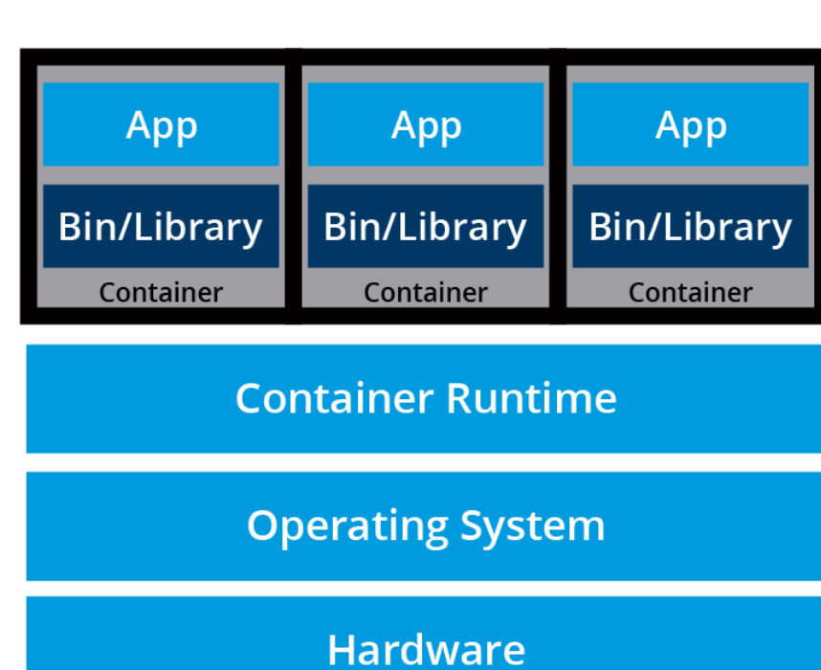

**Microservices** are lightweight applications written in various modern programming languages, with specific dependencies, libraries and environmental requirements. To ensure that an application has everything it needs to run successfully it is packaged together with its dependencies.

Containers encapsulate microservices and their dependencies but do not run them directly. Containers run container images.

**container image** bundles the application along with its runtime, libraries, and dependencies, and it represents the source of a container deployed to offer an isolated executable environment for the application. Containers can be deployed from a specific image on many platforms, such as workstations, Virtual Machines, public cloud, etc.

In Development (Dev) environments, running containers on a single host for development and testing of applications may be a suitable option. However, when migrating to Quality Assurance (QA) and Production (Prod) environments, that is no longer a viable option because the applications and services need to meet specific requirements:

* + - Fault-tolerance
    - On-demand scalability
    - Optimal resource usage
    - Auto-discovery to automatically discover and communicate with each other
    - Accessibility from the outside world
    - Seamless updates/rollbacks without any downtime.

**Container orchestrators** are tools which group systems together to form clusters where containers' deployment and management is automated at scale while meeting the requirements mentioned above. The clustered systems confer the advantages of distributed systems, such as increased performance, cost efficiency, reliability, workload distribution, and reduced latency.

Eg of container orchestration tools,

Amazon ECS (Elastic Container Service) , Azure Container Instances(ACI), Azure Service Fabric (open source), Kubernetes (started by google, now part of Cloud native Computing Foundation{CNCF} project) , Marathon ( run at containers at scale on Apache Mesos & DC/OS), Nomad (HashiCorp) , Docker Swarm (Docker).

Most container orchestrators can be deployed on the infrastructure of our choice - on bare metal, Virtual Machines, on-premises, on public and hybrid clouds. Kubernetes, for example, can be deployed on a workstation, with or without an isolation layer such as a local hypervisor or container runtime, inside a company's data center, in the cloud on AWS Elastic Compute Cloud (EC2) instances, Google Compute Engine (GCE) VMs, DigitalOcean Droplets, IBM Virtual Servers, OpenStack, etc.

In addition, there are turnkey cloud solutions which allow production Kubernetes clusters to be installed, with only a few commands, on top of cloud Infrastructures-as-a-Service. These solutions paved the way for the managed container orchestration as-a-Service, more specifically the managed Kubernetes as-a-Service (KaaS) solution, offered and hosted by the major cloud providers. Examples of KaaS solutions are [Amazon Elastic Kubernetes Service](https://aws.amazon.com/eks/) (Amazon EKS), [Azure Kubernetes Service](https://azure.microsoft.com/en-us/products/kubernetes-service) (AKS), [DigitalOcean Kubernetes](https://www.digitalocean.com/products/kubernetes), [Google Kubernetes Engine](https://cloud.google.com/kubernetes-engine/) (GKE), [IBM Cloud Kubernetes Service](https://www.ibm.com/products/kubernetes-service), [Oracle Container Engine for Kubernetes](https://www.oracle.com/cloud/cloud-native/container-engine-kubernetes/), or [VMware Tanzu Kubernetes Grid](https://tanzu.vmware.com/kubernetes-grid).

KUBERNETES

*Kubernetes is an open-source system for automating deployment, scaling, and management of containerized applications.*

**Kubernetes** comes from the Greek word **κυβερνήτης**, which means *helmsman* or *ship pilot*. With this analogy in mind, we can think of Kubernetes as the pilot on a ship of containers.  
Kubernetes is also referred to as **k8s** (pronounced Kate's), as there are 8 characters between k and s.

Kubernetes is highly inspired by the Google Borg system, a container and workload orchestrator for its global operations, Google has been using for more than a decade. It is an open source project written in the Go language and licensed under the [Apache License, Version 2.0](https://www.apache.org/licenses/LICENSE-2.0).

Kubernetes was started by Google and, with its v1.0 release in July 2015, Google donated it to the [Cloud Native Computing Foundation](https://www.cncf.io/) (CNCF), one of the largest sub-foundations of the [Linux Foundation](https://www.linuxfoundation.org/).

New Kubernetes versions are released in 4 month cycles. The current stable version is ~~1.29 (as of December 2023).~~ 1.31 (released in 13-08-24)

*Google's Borg system is a cluster manager that runs hundreds of thousands of jobs, from many thousands of different applications, across a number of clusters each with up to tens of thousands of machines*

Among the initial authors of Kubernetes were Google employees who have used Borg and developed it in the past. They poured in their valuable knowledge and experience while designing Kubernetes. Several features/objects of Kubernetes that can be traced back to Borg, or to lessons learned from it, are:

* + - API servers
    - Pods
    - IP-per-Pod
    - Services
    - Labels.

Kubernetes offers a very rich set of features for container orchestration. Some of its fully supported features are:

* **Automatic bin packing**  
  Kubernetes automatically schedules containers based on resource needs and constraints, to maximize utilization without sacrificing availability.
* **Designed for extensibility**  
  A Kubernetes cluster can be extended with new custom features without modifying the upstream source code.
* **Self-healing**  
  Kubernetes automatically replaces and reschedules containers from failed nodes. It terminates and then restarts containers that become unresponsive to health checks, based on existing rules/policy. It also prevents traffic from being routed to unresponsive containers.
* **Horizontal scaling**  
  Kubernetes scales applications manually or automatically based on CPU or custom metrics utilization.
* **Service discovery and load balancing**  
  Containers receive IP addresses from Kubernetes, while it assigns a single Domain Name System (DNS) name to a set of containers to aid in load-balancing requests across the containers of the set.

Additional fully supported Kubernetes features are:

* **Automated rollouts and rollbacks**  
  Kubernetes seamlessly rolls out and rolls back application updates and configuration changes, constantly monitoring the application's health to prevent any downtime.
* **Secret and configuration management**  
  Kubernetes manages sensitive data and configuration details for an application separately from the container image, in order to avoid a rebuild of the respective image. Secrets consist of sensitive/confidential information passed to the application without revealing the sensitive content to the stack configuration, like on GitHub.
* **Storage orchestration**  
  Kubernetes automatically mounts software-defined storage (SDS) solutions to containers from local storage, external cloud providers, distributed storage, or network storage systems.
* **Batch execution**  
  Kubernetes supports batch execution, long-running jobs, and replaces failed containers.
* **IPv4/IPv6 dual-stack**  
  Kubernetes supports both IPv4 and IPv6 addresses.

Kubernetes supports common Platform as a Service specific features such as application deployment, scaling, and load balancing, but allows users to integrate their desired monitoring, logging and alerting solutions through optional plugins.

There are many additional features currently in alpha or beta phase. They will add great value to any Kubernetes deployment once they become stable features. For example, support for role-based access control (RBAC) is stable only as of the Kubernetes 1.8 release, while cronjob support is stable only as of release 1.21.

Another one of Kubernetes' strengths is portability. It can be deployed in many environments such as local or remote Virtual Machines, bare metal, or in public/private/hybrid/multi-cloud setups.

For a successful open source project, the community is as important as having great code. Kubernetes is supported by a thriving community across the world. It has more than 3,500 contributors. The community is divided into *Special Interest Groups* (SIGs), groups which focus on special topics, such as scaling, bare metal, networking, storage, etc.

KUBERNETES USERS

Kubernetes is a solution for workload management in banking, education, finance and investments, gaming, information technology, media and streaming, online retail, ridesharing, telecommunications, nuclear research, and many other industries. There are numerous user [case studies](https://kubernetes.io/case-studies/) and success stories on the Kubernetes website:

* + - [BlackRock](https://kubernetes.io/case-studies/blackrock/)
    - [Booking.com](https://kubernetes.io/case-studies/booking-com/)
    - [Box](https://kubernetes.io/case-studies/box/)
    - [CapitalOne](https://kubernetes.io/case-studies/capital-one/)
    - [Huawei](https://kubernetes.io/case-studies/huawei/)
    - [IBM](https://kubernetes.io/case-studies/ibm/)
    - [ING](https://kubernetes.io/case-studies/ing/)
    - [Nokia](https://kubernetes.io/case-studies/nokia/)
    - [OpenAI](https://kubernetes.io/case-studies/openai/)
    - [Pearson](https://kubernetes.io/case-studies/pearson/)
    - [Spotify](https://kubernetes.io/case-studies/spotify/)
    - [Wikimedia](https://kubernetes.io/case-studies/wikimedia/)

For Kubernetes, the Cloud Native Computing Foundation:

* Provides a neutral home for the Kubernetes trademark and enforces proper usage.
* Provides license scanning of core and vendor code.
* Offers legal guidance on patent and copyright issues.
* Creates and maintains open source learning [curriculum](https://github.com/cncf/curriculum), [training](https://www.cncf.io/training/courses/), and [certification](https://www.cncf.io/training/certification/) for Kubernetes and cloud native associates (KCNA), Kubernetes administrators (CKA), Kubernetes application developers (CKAD), Kubernetes security specialists (CKS) and more.
* Manages a software conformance [working group](https://lists.cncf.io/g/cncf-k8s-conformance).
* Actively markets Kubernetes.
* Supports ad hoc activities.
* Sponsors conferences and meetup events.

At a very high level, Kubernetes is a cluster of compute systems categorized by their distinct roles:

* + One or more **control plane** nodes
  + One or more **worker** nodes (optional, but recommended).

(NOTE to SELF # REFER HAND NOTES FROM THIS POINT AS WELL)

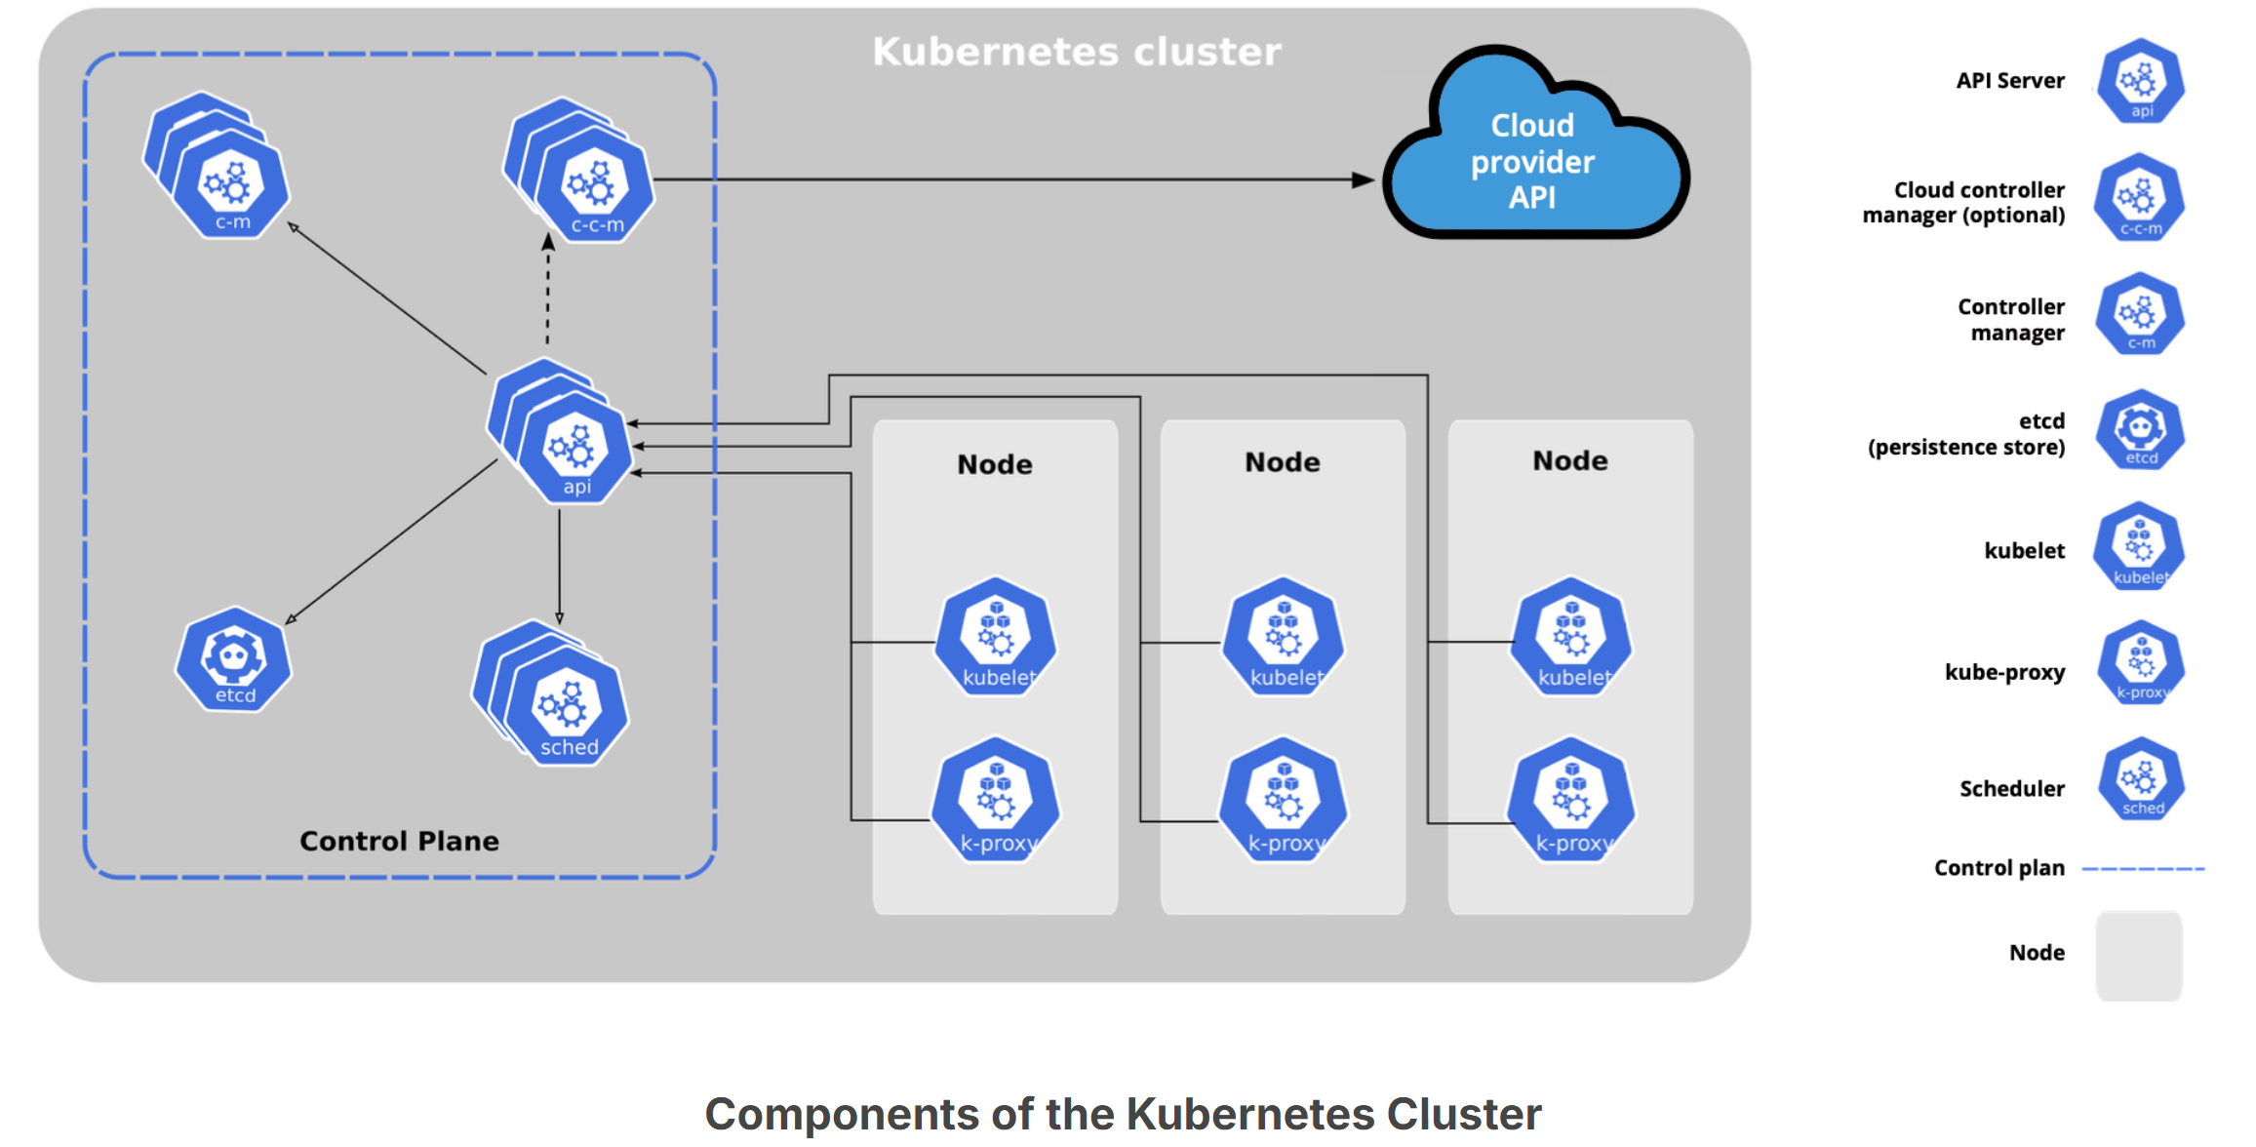

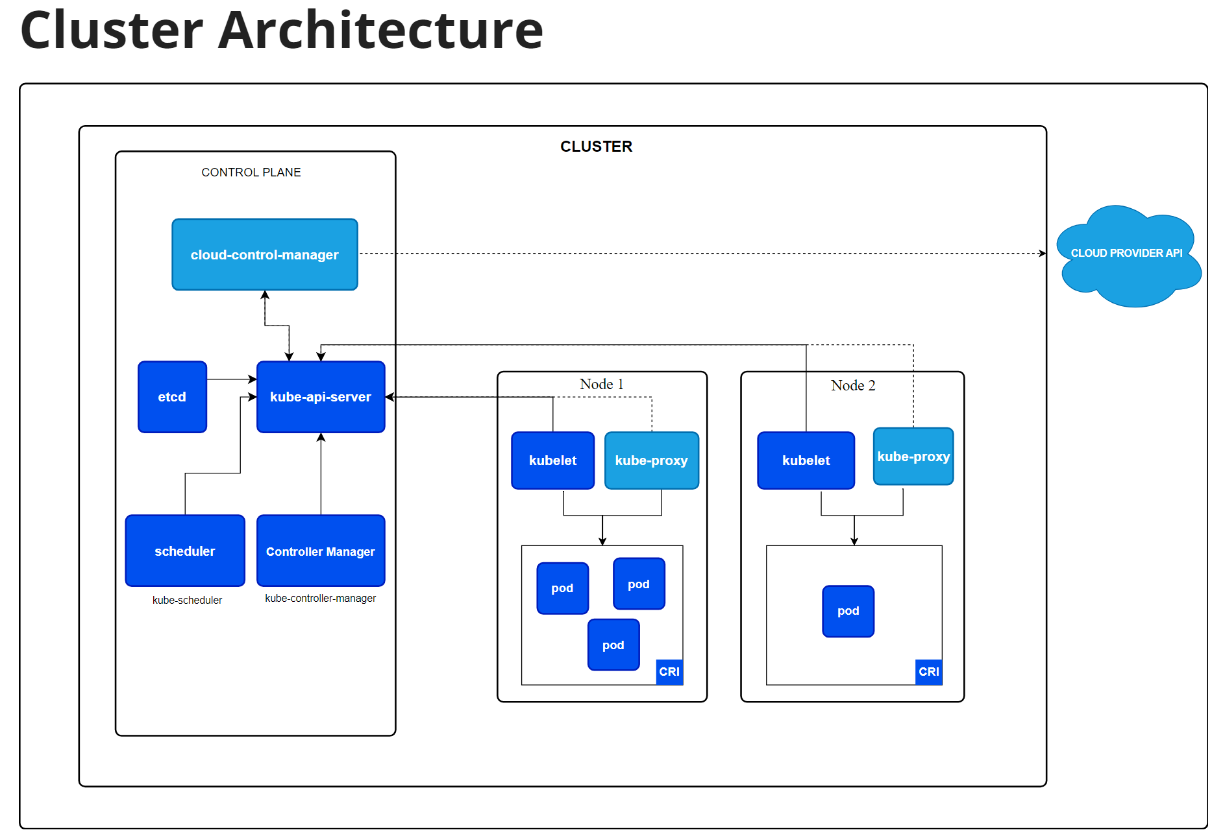

The **control plane node** provides a running environment for the **control plane agents** responsible for managing the state of a Kubernetes cluster, and it is the brain behind all operations inside the cluster. The control plane components are agents with very distinct roles in the cluster's management. In order to communicate with the Kubernetes cluster, users send requests to the control plane via a Command Line Interface (CLI) tool, a Web User-Interface (Web UI) Dashboard, or an Application Programming Interface (API).

A control plane node runs the following essential control plane components and agents:

* + - API Server
    - Scheduler
    - Controller Managers
    - Key-Value Data Store

In addition, the control plane node runs:

* + - Container Runtime
    - Node Agent - kubelet
    - Proxy - kube-proxy
    - Optional add-ons for observability, such as dashboards, cluster-level monitoring, and logging

The **control plane node** provides a running environment for the **control plane agents** responsible for managing the state of a Kubernetes cluster, and it is the brain behind all operations inside the cluster. The control plane components are agents with very distinct roles in the cluster's management. In order to communicate with the Kubernetes cluster, users send requests to the control plane via a Command Line Interface (CLI) tool, a Web User-Interface (Web UI) Dashboard, or an Application Programming Interface (API).

It is important to keep the control plane running at all costs. Losing the control plane may introduce downtime, causing service disruption to clients, with possible loss of business. To ensure the control plane's fault tolerance, control plane node replicas can be added to the cluster, configured in High-Availability (HA) mode. While only one of the control plane nodes is dedicated to actively managing the cluster, the control plane components stay in sync across the control plane node replicas. This type of configuration adds resiliency to the cluster's control plane, should the active control plane node fail.

To persist the Kubernetes cluster's state, all cluster configuration data is saved to a distributed key-value store which only holds cluster state related data, no client workload generated data. The key-value store may be configured on the control plane node (stacked topology), or on its dedicated host (external topology) to help reduce the chances of data store loss by decoupling it from the other control plane agents.In the stacked key-value store topology, HA control plane node replicas ensure the key-value store's resiliency as well. However, that is not the case with external key-value store topology, where the dedicated key-value store hosts have to be separately replicated for HA, a configuration that introduces the need for additional hardware, hence additional operational costs.

All the administrative tasks are coordinated by the **kube-apiserver**, a central control plane component running on the control plane node. The API Server intercepts RESTful calls from users, administrators, developers, operators and external agents, then validates and processes them. During processing the API Server reads the Kubernetes cluster's current state from the key-value store, and after a call's execution, the resulting state of the Kubernetes cluster is saved in the key-value store for persistence. The API Server is the only control plane component to talk to the key-value store, both to read from and to save Kubernetes cluster state information - acting as a middle interface for any other control plane agent inquiring about the cluster's state.

The role of the **kube-scheduler** is to assign new workload objects, such as pods encapsulating containers, to nodes - typically worker nodes. During the scheduling process, decisions are made based on current Kubernetes cluster state and new workload object's requirements. The scheduler obtains from the key-value store, via the API Server, resource usage data for each worker node in the cluster.

A scheduler is extremely important and complex in a multi-node Kubernetes cluster, while in a single-node Kubernetes cluster possibly used for learning and development purposes, the scheduler's job is quite simple.

The **controller managers** are components of the control plane node running controllers or operator processes to regulate the state of the Kubernetes cluster. Controllers are watch-loop processes continuously running and comparing the cluster's desired state (provided by objects' configuration data) with its current state (obtained from the key-value store via the API Server). In case of a mismatch, corrective action is taken in the cluster until its current state matches the desired state.

The **kube-controller-manager** runs controllers or operators responsible to act when nodes become unavailable, to ensure container pod counts are as expected, to create endpoints, service accounts, and API access tokens.

The **cloud-controller-manager** runs controllers or operators responsible to interact with the underlying infrastructure of a cloud provider when nodes become unavailable, to manage storage volumes when provided by a cloud service, and to manage load balancing and routing.

**Key-Value Data Store**

[**etcd**](https://etcd.io/) is an open source project under the [Cloud Native Computing Foundation](https://www.cncf.io/) (CNCF). etcd is a strongly consistent, distributed **key-value data store** used to persist a Kubernetes cluster's state. New data is written to the data store only by appending to it, data is never replaced in the data store. Obsolete data is compacted (or shredded) periodically to minimize the size of the data store.

etcd's CLI management tool - **etcdctl**, provides snapshot save and restore capabilities which come in handy especially for a single etcd instance Kubernetes cluster - common in Development and learning environments. However, in Stage and Production environments, it is extremely important to replicate the data stores in HA mode, for cluster configuration data resiliency.

Some Kubernetes cluster bootstrapping tools, such as **kubeadm**, by default, provision stacked etcd control plane nodes, where the data store runs alongside and shares resources with the other control plane components on the same control plane node.

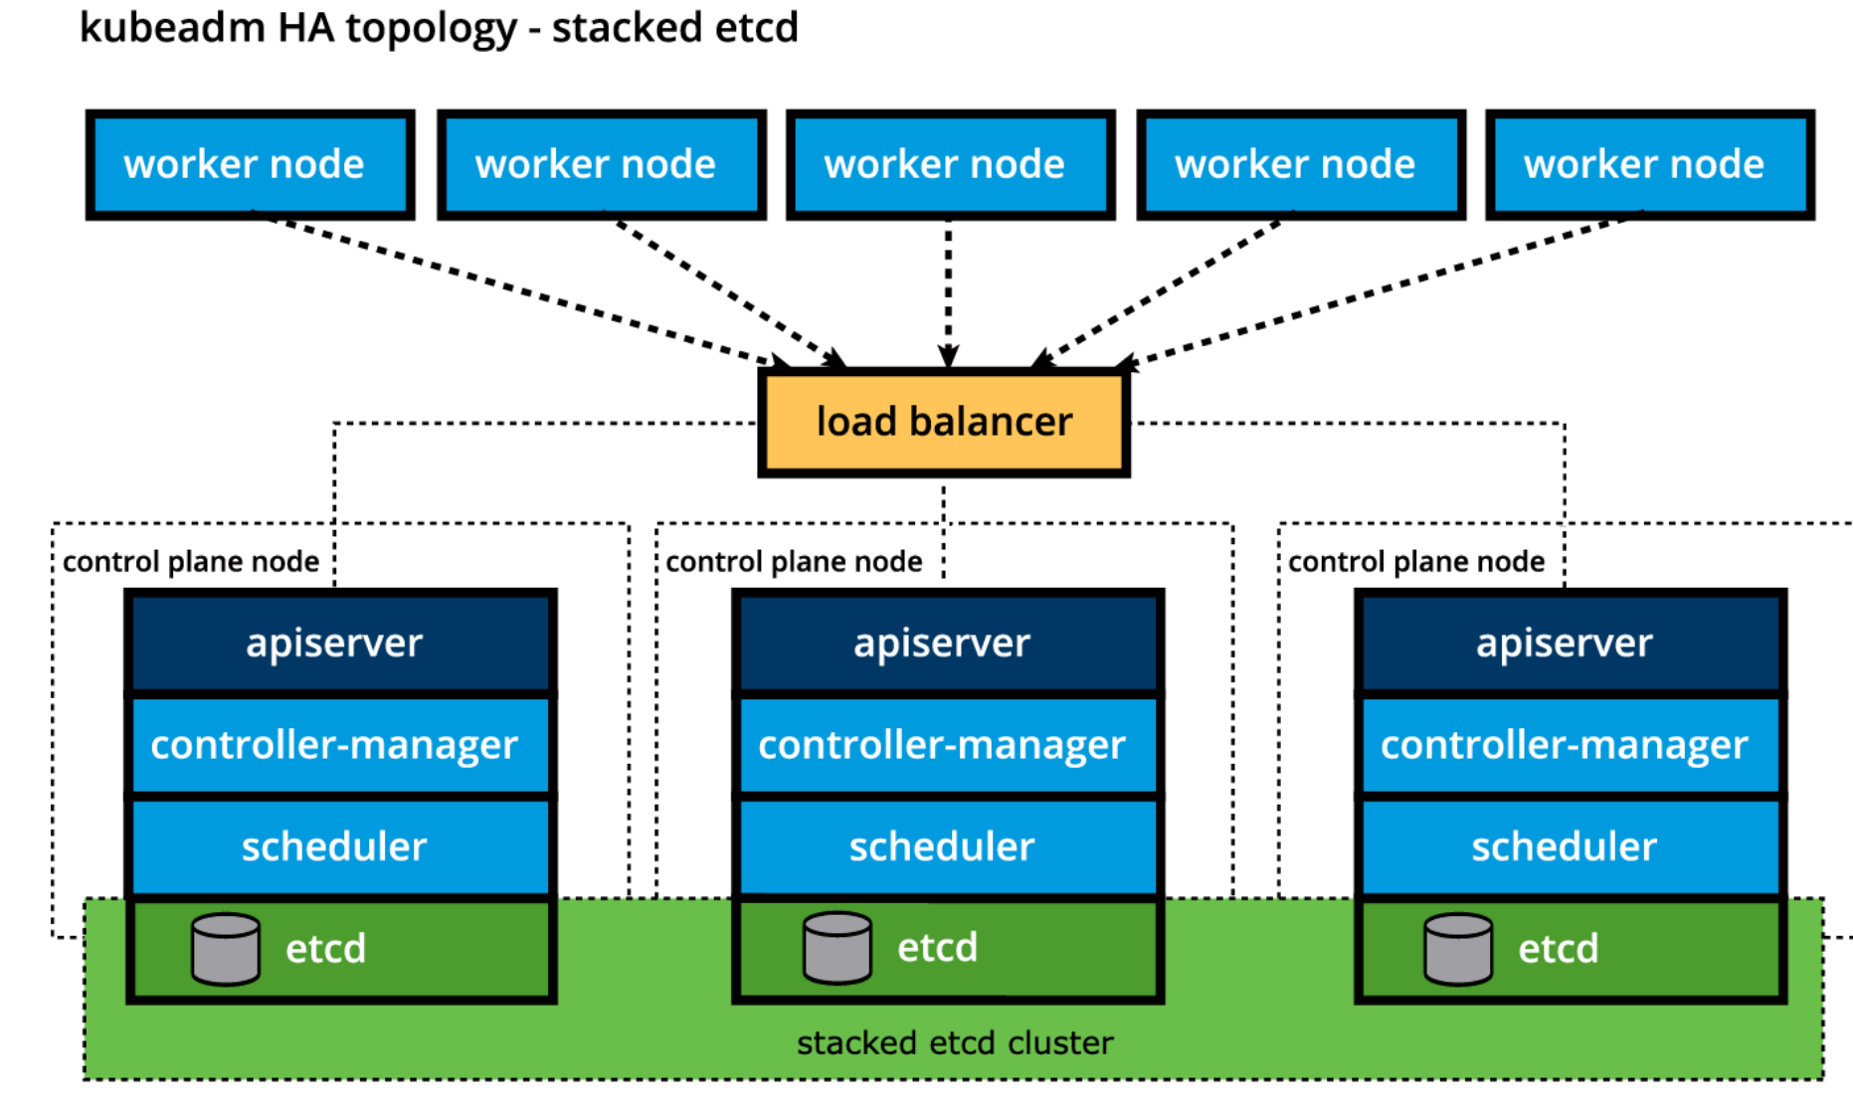

For data store isolation from the control plane components, the bootstrapping process can be configured for an external etcd topology, where the data store is provisioned on a dedicated separate host, thus reducing the chances of an etcd failure.

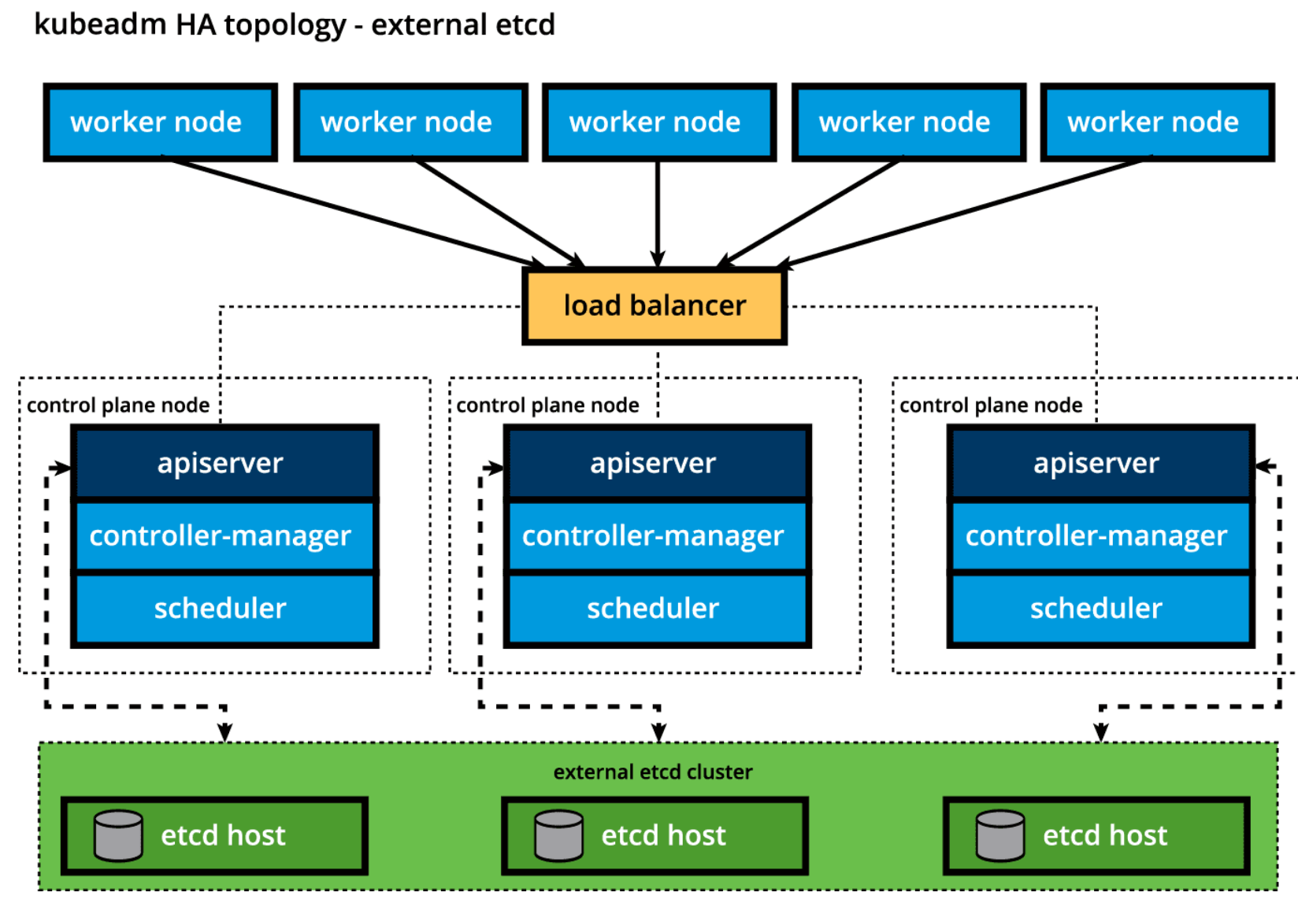

Both stacked and external etcd topologies support HA configurations. etcd is based on the [Raft Consensus Algorithm](https://raft.github.io/) which allows a collection of machines to work as a coherent group that can survive the failures of some of its members. At any given time, one of the nodes in the group will be the leader, and the rest of them will be the followers. etcd gracefully handles leader elections and can tolerate node failure, including leader node failures. Any node can be treated as a leader.

Keep in mind however, that the leader/followers hierarchy is distinct from the primary/secondary hierarchy, meaning that neither node is favored for the leader role, and neither node outranks other nodes. A leader will remain active until it fails, at which point in time a new leader is elected by the group of healthy followers.

etcd is written in the Go programming language. In Kubernetes, besides storing the cluster state, etcd is also used to store configuration details such as subnets, ConfigMaps, Secrets, etc.

A **worker node** provides a running environment for client applications. These applications are microservices running as application containers. In Kubernetes the application containers are encapsulated in Pods, controlled by the cluster control plane agents running on the control plane node. Pods are scheduled on worker nodes, where they find required compute, memory and storage resources to run, and networking to talk to each other and the outside world.

A Pod is the smallest scheduling work unit in Kubernetes. It is a logical collection of one or more containers scheduled together, and the collection can be started, stopped, or rescheduled as a single unit of work.

Also, in a multi-worker Kubernetes cluster, the network traffic between client users and the containerized applications deployed in Pods is handled directly by the worker nodes, and is not routed through the control plane node.

A worker node has the following components:

* + - Container Runtime
    - Node Agent - kubelet
    - Proxy - kube-proxy
    - Add-ons for DNS, observability components such as dashboards, cluster-level monitoring and logging, and device plugins.

Although Kubernetes is described as a "container orchestration engine", it lacks the capability to directly handle and run containers. In order to manage a container's lifecycle, Kubernetes requires a **container runtime** on the node where a Pod and its containers are to be scheduled. A runtime is required on each nod of a Kubernetes cluster, both control plane and worker. The [recommendation](https://kubernetes.io/docs/setup/) is to run the Kubernetes control plane components as containers, hence the necessity of a runtime on the control plane nodes. Kubernetes supports several container runtimes:

* [CRI-O](https://cri-o.io/)A lightweight container runtime for Kubernetes, supporting [quay.io](https://quay.io/) and [Docker Hub](https://hub.docker.com/) image registries.
* [containerd](https://containerd.io/)A simple, robust, and portable container runtime.
* [Docker Engine](https://www.docker.com/)  
  A popular and complex container platform which uses **containerd** as a container runtime.
* [Mirantis Container Runtime](https://www.mirantis.com/software/container-runtime/)Formerly known as the **Docker Enterprise Edition**.

The **kubelet** is an agent running on each node, control plane and workers, and it communicates with the control plane. It receives Pod definitions, primarily from the API Server, and interacts with the container runtime on the node to run containers associated with the Pod. It also monitors the health and resources of Pods running containers.

The kubelet connects to container runtimes through a plugin based interface - the [Container Runtime Interface](https://github.com/kubernetes/community/blob/master/contributors/devel/sig-node/container-runtime-interface.md) (CRI). The CRI consists of protocol buffers, gRPC API, libraries, and additional specifications and tools. In order to connect to interchangeable container runtimes, kubelet uses a **CRI shim**, an application which provides a clear abstraction layer between kubelet and the container runtime.

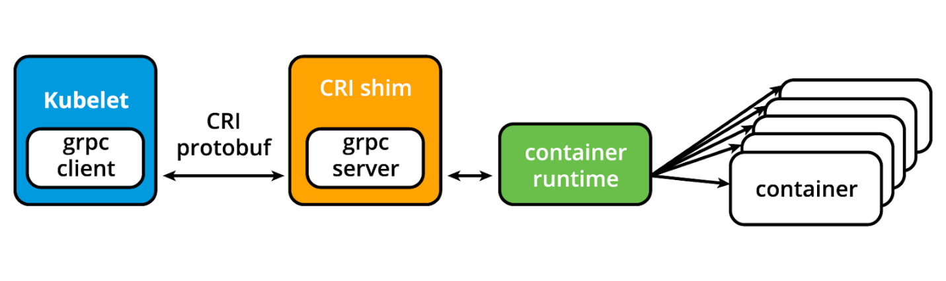As shown above, the kubelet acting as grpc client connects to the CRI shim acting as grpc server to perform container and image operations. The CRI implements two services: **ImageService** and **RuntimeService**. The **ImageService** is responsible for all the image-related operations, while the **RuntimeService** is responsible for all the Pod and container-related operations.

Kubernetes started migrating towards a standardized approach to container runtime integration by introducing the CRI. Kubernetes adopted a decoupled and flexible method to integrate with various container runtimes without the need to recompile its source code. Any container runtime that implements the CRI could be used by Kubernetes to manage containers.

Shims are Container Runtime Interface (CRI) implementations, interfaces or adapters, specific to each container runtime supported by Kubernetes.

Examples are:

**cri-containerd**cri-containerd allows containers to be directly created and managed with containerd at kubelet's request:

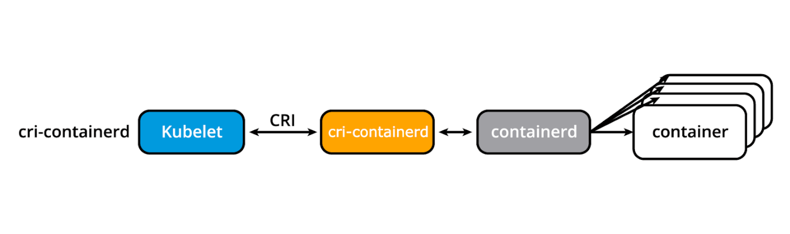

**cri-containerd**

**CRI-O**  
CRI-O enables the use of any Open Container Initiative (OCI) compatible runtime with Kubernetes, such as runC:

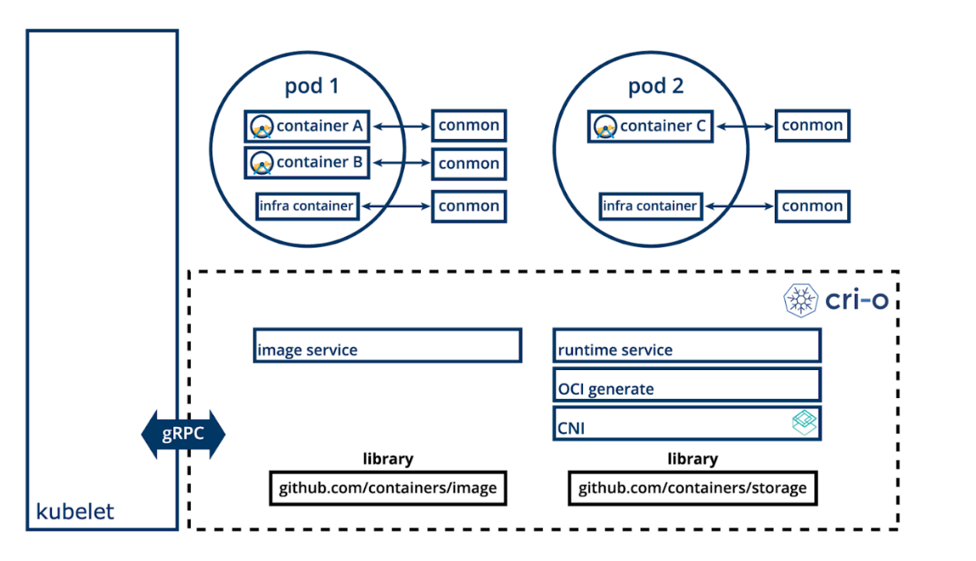

**CRI-O**

**dockershim and cri-dockerd**Before Kubernetes release v1.24 the **dockershim** allowed containers to be created and managed by invoking the Docker Engine and its internal runtime containerd. Due to Docker Engine's popularity, this shim has been the default interface used by kubelet. However, starting with Kubernetes release v1.24, the dockershim is no longer being maintained by the Kubernetes project, its specific code is removed from kubelet source code, thus will no longer be supported by the kubelet node agent of Kubernetes. As a result, [Docker, Inc.,](https://www.docker.com/)and [Mirantis](https://www.mirantis.com/) have agreed to introduce and maintain a replacement adapter, **cri-dockerd** that would ensure that the Docker Engine will continue to be a container runtime option for Kubernetes, in addition to the Mirantis Container Runtime (MCR). The introduction of cri-dockerd also ensures that both Docker Engine and MCR follow the same standardized integration method as the CRI-compatible runtimes. 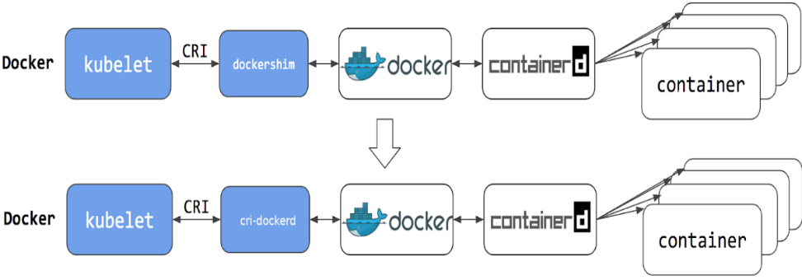

**dockershim to cri-dockerd**

Additional details about the deprecation process of the dockershim can be found on the [Updated: Dockershim Removal FAQ](https://kubernetes.io/blog/2022/02/17/dockershim-faq/) page.

The **kube-proxy** is the network agent which runs on each node, control plane and workers, responsible for dynamic updates and maintenance of all networking rules on the node. It abstracts the details of Pods networking and forwards connection requests to the containers in the Pods.

The kube-proxy is responsible for TCP, UDP, and SCTP stream forwarding or random forwarding across a set of Pod backends of an application, and it implements forwarding rules defined by users through Service API objects.

The kube-proxy node agent operates in conjunction with the iptables of the node. Iptables is a firewall utility created for the Linux OS that can be managed by users through a CLI utility of the same name. The iptables utility is available for and pre-installed on many Linux distributions.

**Add-ons** are cluster features and functionality not yet available in Kubernetes, therefore implemented through 3rd-party pods and services.

* **DNS**Cluster DNS is a DNS server required to assign DNS records to Kubernetes objects and resources.
* **Dashboard**   
  A general purpose web-based user interface for cluster management.
* **Monitoring**   
  Collects cluster-level container metrics and saves them to a central data store.
* **Logging**   
  Collects cluster-level container logs and saves them to a central log store for analysis.
* **Device plugins**  
  For system hardware resources, such as GPU, FPGA, high-performance NIC, to be advertised by the node to application pods

**NETWORKING CHALLENGES** (SKIPPED--)

Decoupled microservices based applications rely heavily on networking in order to mimic the tight-coupling once available in the monolithic era. Networking, in general, is not the easiest to understand and implement. Kubernetes is no exception - as a containerized microservices orchestrator it needs to address a few distinct networking challenges:

* Container-to-Container communication inside Pods
* Pod-to-Pod communication on the same node and across cluster nodes
* Service-to-Pod communication within the same namespace and across cluster namespaces
* External-to-Service communication for clients to access applications in a cluster

All these networking challenges must be addressed by a Kubernetes cluster and its plugins.

Container-to-Container communication inside Pods

Making use of the underlying host operating system's kernel virtualization features, a container runtime creates an isolated network space for each container it starts. On Linux, this isolated network space is referred to as a **network namespace**. A network namespace can be shared across containers, or with the host operating system.

When a grouping of containers defined by a Pod is started, a special infrastructure **Pause container** is initialized by the Container Runtime for the sole purpose of creating a network namespace for the Pod. All additional containers, created through user requests, running inside the Pod will share the Pause container's network namespace so that they can all talk to each other via localhost.

Pod-to-Pod communication on the same node and across cluster nodes

(and)

Service-to-Pod communication within the same namespace and across cluster namespaces

In a Kubernetes cluster Pods, groups of containers, are scheduled on nodes in a nearly unpredictable fashion. Regardless of their host node, Pods are expected to be able to communicate with all other Pods in the cluster, all this without the implementation of Network Address Translation (NAT). This is a fundamental requirement of any networking implementation in Kubernetes.

The Kubernetes network model aims to reduce complexity, and it treats Pods as VMs on a network, where each VM is equipped with a network interface - thus each Pod receiving a unique IP address. This model is called "**IP-per-Pod**" and ensures Pod-to-Pod communication, just as VMs are able to communicate with each other on the same network.

Let's not forget about containers though. They share the Pod's network namespace and must coordinate ports assignment inside the Pod just as applications would on a VM, all while being able to communicate with each other on **localhost** - inside the Pod. However, containers are integrated with the overall Kubernetes networking model through the use of the [Container Network Interface](https://www.cni.dev/) (CNI) supported by [CNI plugins](https://github.com/containernetworking/cni#3rd-party-plugins). CNI is a set of specifications and libraries which allow plugins to configure the networking for containers. While there are a few [core plugins](https://github.com/containernetworking/plugins#plugins), most CNI plugins are 3rd-party Software Defined Networking (SDN) solutions implementing the Kubernetes networking model. In addition to addressing the fundamental requirement of the networking model, some networking solutions offer support for Network Policies. [Flannel](https://github.com/coreos/flannel/), [Weave](https://www.weave.works/oss/net/), [Calico](https://www.tigera.io/project-calico/), and [Cilium](https://cilium.io/) are only a few of the SDN solutions available for Kubernetes clusters.

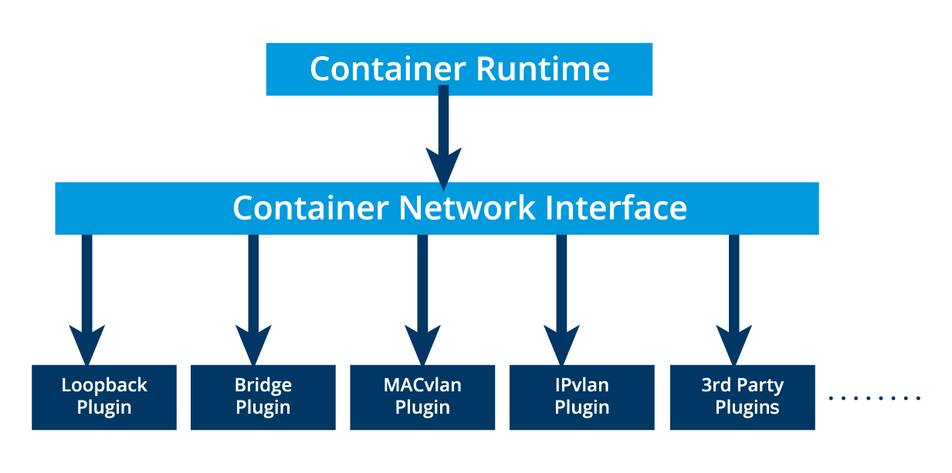

**Container Network Interface (CNI) Core Plugins**

The container runtime offloads the IP assignment to CNI, which connects to the underlying configured plugin, such as Bridge or MACvlan, to get the IP address. Once the IP address is given by the respective plugin, CNI forwards it back to the requested container runtime.

For more details-> [Kubernetes documentation](https://kubernetes.io/docs/concepts/cluster-administration/networking/).

External-to-Service communication for clients to access applications in a cluster

A successfully deployed containerized application running in Pods inside a Kubernetes cluster may require accessibility from the outside world. Kubernetes enables external accessibility through **Services**, complex encapsulations of network routing rule definitions stored in **iptables** on cluster nodes and implemented by **kube-proxy** agents. By exposing services to the external world with the aid of **kube-proxy**, applications become accessible from outside the cluster over a virtual IP address and a dedicated port number.

## ***KUBERNETES COFIGURATION***

Kubernetes can be installed using different cluster configurations. The major installation types are described below:

* **All-in-One Single-Node Installation**  
  In this setup, all the control plane and worker components are installed and running on a single-node. While it is useful for learning, development, and testing, it is not recommended for production purposes.
* **Single-Control Plane and Multi-Worker Installation**  
  In this setup, we have a single-control plane node running a stacked etcd instance. Multiple worker nodes can be managed by the control plane node.
* **Single-Control Plane with Single-Node etcd, and Multi-Worker Installation**  
  In this setup, we have a single-control plane node with an external etcd instance. Multiple worker nodes can be managed by the control plane node.
* **Multi-Control Plane and Multi-Worker Installation**  
  In this setup, we have multiple control plane nodes configured for High-Availability (HA), with each control plane node running a stacked etcd instance. The etcd instances are also configured in an HA etcd cluster and multiple worker nodes can be managed by the HA control plane.
* **Multi-Control Plane with Multi-Node etcd, and Multi-Worker Installation**  
  In this setup, we have multiple control plane nodes configured in HA mode, with each control plane node paired with an external etcd instance. The external etcd instances are also configured in an HA etcd cluster, and multiple worker nodes can be managed by the HA control plane. This is the most advanced cluster configuration recommended for production environments.

As the Kubernetes cluster's complexity grows, so does its hardware and resources requirements. While we can deploy Kubernetes on a single host for learning, development, and possibly testing purposes, the community recommends multi-host environments that support High-Availability control plane setups and multiple worker nodes for client workload for production purposes.

(infrastructure?)

Once we decide on the installation type, we need to decide on the infrastructure. Infrastructure related decisions are typically guided by the desired environment type, either learning or production environment. For infrastructure, we need to decide on the following:

* + - Should we set up Kubernetes on bare metal, public cloud, private, or hybrid cloud?
    - Which underlying OS should we use? Should we choose a Linux distribution - Red Hat-based or Debian-based, or Windows?
    - Which networking solution (CNI) should we use?

**INSTALLING LOCAL CLUSTERS**

There are a variety of installation tools allowing us to deploy single- or multi-node Kubernetes clusters on our workstations, for learning and development purposes. While not an exhaustive list, below we enumerate a few popular ones:

* [Minikube](https://minikube.sigs.k8s.io/docs/)  
  Single- and multi-node local Kubernetes cluster, recommended for a learning environment deployed on a single host.
* [Kind](https://kind.sigs.k8s.io/)  
  Multi-node Kubernetes cluster deployed in Docker containers acting as Kubernetes nodes, recommended for a learning environment.
* [Docker Desktop](https://www.docker.com/products/docker-desktop)   
  Including a local Kubernetes cluster for Docker users.
* [Podman Desktop](https://podman-desktop.io/)  
  Including Kubernetes integration for Podman users.
* [MicroK8s](https://microk8s.io/)   
  Local and cloud Kubernetes cluster for developers and production, from Canonical.
* [K3S](https://k3s.io/)   
  Lightweight Kubernetes cluster for local, cloud, edge, IoT deployments, originally from Rancher, currently a CNCF project.

PRODUCTION CLUSTERS w/ Deployment Tools

When it comes to production ready solutions, there are several recommended tools for Kubernetes cluster bootstrapping and a few that are also capable of provisioning the necessary hosts on the underlying infrastructure.

(most popular tools ->)

**kubeadm**[kubeadm](https://kubernetes.io/docs/setup/production-environment/tools/kubeadm/) is a first-class citizen of the Kubernetes ecosystem. It is a secure and recommended method to bootstrap a multi-node production ready Highly Available Kubernetes cluster, on-premises or in the cloud. kubeadm can also bootstrap a single-node cluster for learning. It has a set of building blocks to set up the cluster, but it is easily extendable to add more features. Please note that kubeadm does not support the provisioning of hosts - they should be provisioned separately with a tool of our choice.

**kubespray**  
[kubespray](https://kubespray.io/#/) (formerly known as kargo) allows us to install Highly Available production ready Kubernetes clusters on AWS, GCP, Azure, OpenStack, vSphere, or bare metal. kubespray is based on Ansible, and is available on most Linux distributions. Explore the [kubespray project](https://github.com/kubernetes-sigs/kubespray) for more details.

**kops**  
[kops](https://kops.sigs.k8s.io/) enables us to create, upgrade, and maintain production-grade, Highly Available Kubernetes clusters from the command line. It can provision the required infrastructure as well. Currently, AWS and GCE are officially supported. Support for DigitalOcean and OpenStack is in beta, while Azure is in alpha support, and other platforms are planned for the future. Explore the [kops project](https://github.com/kubernetes/kops/) for more details.

In addition, for a manual installation approach, the [*Kubernetes The Hard Way*](https://github.com/kelseyhightower/kubernetes-the-hard-way) GitHub project by [Kelsey Hightower](https://twitter.com/kelseyhightower) is an extremely helpful installation guide and resource. The project aims to teach all the detailed steps involved in the bootstrapping of a Kubernetes cluster, steps that are otherwise automated by various tools mentioned in this chapter and obscured from the end user.

Kubernetes & Windows

Kubernetes v1.14, Windows was successfully introduced as a [supported](https://kubernetes.io/docs/setup/production-environment/windows/intro-windows-in-kubernetes/) production ready operating system only for worker nodes of a Kubernetes cluster. This enabled Kubernetes to support the deployment of Windows containers in the cluster, either as a dedicated Windows cluster, or a hybrid cluster with Windows nodes running alongside Linux nodes. Keep in mind, however, that the control plane nodes are limited to running on Linux only, with no plans to extend the support to Windows control plane nodes.

With Windows Server 2019 and Windows Server 2022 being the only Windows OS supported by Kubernetes, the same container workload orchestration tool can [schedule](https://kubernetes.io/docs/setup/production-environment/windows/user-guide-windows-containers/) and deploy both Linux and Windows containers in the same cluster. The user is responsible to configure the workload scheduling according to the expected OS, that is to schedule Linux and Windows containers on nodes with their respective operating systems when nodes of each OS coexist in the same Kubernetes cluster.

***MINIKUBE***

[Minikube](https://minikube.sigs.k8s.io/) is one of the easiest, most flexible and popular methods to run an all-in-one or a multi-node local Kubernetes cluster, isolated by Virtual Machines (VM) or Containers, run directly on our workstations. Minikube is the tool responsible for the installation of Kubernetes components, cluster bootstrapping, and cluster tear-down when no longer needed. It includes additional features aimed to ease the user interaction with the Kubernetes cluster, but nonetheless, it initializes for us a fully functional, non-production, Kubernetes cluster extremely convenient for learning purposes. Minikube can be installed on native macOS, Windows, and many Linux distributions.

However, in order to fully take advantage of all the features Minikube has to offer, a [Type-2 Hypervisor](https://en.wikipedia.org/wiki/Hypervisor) or a Container Runtime should be installed on the local workstation, to run in conjunction with Minikube. The role of the hypervisor or container runtime is to offer an isolated infrastructure for the Minikube Kubernetes cluster components, that is easily reproducible, easy to use and tear down. This isolation of the cluster components from our daily environment ensures that once no longer needed, the Minikube components can be safely removed leaving behind no configuration changes to our workstation, thus no traces of their existence. Minikube includes the necessary adapters to interact directly with the isolation software of choice to build all its infrastructure as long as the Type-2 Hypervisor or Container Runtime is installed on our workstation.

Minikube is built on the capabilities of the [libmachine](https://github.com/docker/machine/tree/master/libmachine) library originally designed by Docker to build [Virtual Machine container hosts](https://github.com/docker/machine) on any physical infrastructure. In time Minikube became very flexible, supporting several hypervisors and container runtimes, depending on the host workstation's native OS.

Minikube can be installed without an isolation software, on bare-metal, which may result in permanent configuration changes to the host OS. To prevent such permanent configuration changes, a second form of isolation can be achieved by installing Minikube inside a Virtual Machine provisioned with a Type-2 Hypervisor of choice, and a desktop guest OS of choice (with enabled GUI). As a result, when installed inside a VM, Minikube will end up making configuration changes to the guest environment, still isolated from the host workstation. Therefore, now we have two distinct methods to isolate the Minikube environment from our host workstation.

The isolation software can be specified by the user with the **--driver** option, otherwise Minikube will try to find a preferred method for the host OS of the workstation.

Once decided on the isolation method, the next step is to determine the required number of Kubernetes cluster nodes, and their sizes in terms of CPU, memory, and disk space. Minikube invokes the hypervisor of choice to provision the infrastructure VM(s) which will host the Kubernetes cluster node(s), or the runtime of choice to run infrastructure container(s) that host the cluster node(s). Keep in mind that Minikube now supports all-in-one single-node and multi-node clusters. Regardless of the isolation method and the expected cluster and node sizes, a local Minikube Kubernetes cluster will ultimately be impacted and/or limited by the physical resources of the host workstation. We have to be mindful of the needs of the host OS and any utilities it may be running, then the needs of the hypervisor or the container runtime, and finally the remaining resources that can be allocated to our Kubernetes cluster. For a learning environment the recommendations are that a Kubernetes node has 2 CPU cores (or virtual CPUs) at a minimum, at least 2 GB of RAM memory (with 4 - 8 GB of RAM recommended for optimal usage), and 20+ GB of disk storage space. When migrating towards a larger, more dynamic, production grade cluster, these resource values should be adjusted accordingly. The Kubernetes nodes are expected to access the internet as well, for software updates, container image downloads, and for client accessibility.

Following the node(s)' provisioning phase, Minikube invokes [kubeadm](https://kubernetes.io/docs/setup/production-environment/tools/kubeadm/create-cluster-kubeadm/), to bootstrap the Kubernetes cluster components inside the previously provisioned node(s). We need to ensure that we have the necessary hardware and software required by Minikube to build our environment.

**REQUIREMENTS FOR MINIKUBE**

* VT-x/AMD-v virtualization may need to be enabled on the local workstation for certain hypervisors.
* [kubectl](https://kubernetes.io/docs/tasks/tools/install-kubectl/)  
  **kubectl** command line client (CLI) is a binary used to access and manage any Kubernetes cluster. It is installed through Minikube and accessed through the **minikube kubectl** command, or it can be installed separately and run as a standalone tool. We will explore **kubectl** installation and usage in future chapters.
* Type-2 Hypervisor or Container Runtime  
  Without a specified driver, Minikube will try to find an installed hypervisor or a runtime, in the following order of preference (on a Linux host): docker, kvm2, podman, vmware, and virtualbox. If multiple isolation software installations are found, such as docker and virtualbox, Minikube will pick docker over virtualbox if no desired driver is specified by the user. Hypervisors and Container Runtimes supported by various native workstation OSes:  
  - On Linux [VirtualBox](https://www.virtualbox.org/wiki/Downloads), [KVM2](https://www.linux-kvm.org/page/Main_Page), and [QEMU](https://www.qemu.org/) hypervisors, or [Docker](https://docs.docker.com/engine/install/) and [Podman](https://podman.io/getting-started/installation.html) runtimes  
  - On macOS [VirtualBox](https://www.virtualbox.org/wiki/Downloads), [HyperKit](https://github.com/moby/hyperkit), [VMware Fusion](http://www.vmware.com/products/fusion.html), [Parallels](https://www.parallels.com/), and [QEMU](https://www.qemu.org/) hypervisors, or [Docker](https://docs.docker.com/desktop/mac/install/) and [Podman](https://podman.io/getting-started/installation.html) runtimes  
  - On Windows [VirtualBox](https://www.virtualbox.org/wiki/Downloads), [Hyper-V](https://docs.microsoft.com/en-us/virtualization/hyper-v-on-windows/quick-start/enable-hyper-v), [VMware Workstation](https://www.vmware.com/in/products/workstation-pro/workstation-pro-evaluation.html), and [QEMU](https://www.qemu.org/) hypervisors, or [Docker](https://docs.docker.com/desktop/windows/install/) and [Podman](https://podman.io/getting-started/installation.html) runtimes.

***NOTE:****Minikube supports a*[***--driver=none***](https://minikube.sigs.k8s.io/docs/drivers/none/)*(on Linux) option that runs the Kubernetes components bare-metal, directly on the host OS and not inside a VM. With this option a Docker installation is required and a Linux OS on the local workstation, but no hypervisor installation.****This driver is recommended for advanced users.***

* Internet connection on the first Minikube run - to download packages, dependencies, updates and pull images needed to initialize the Minikube Kubernetes cluster components. Subsequent Minikube runs will require an Internet connection only when new container images need to be pulled from a public container registry or when deployed containerized applications need it for client accessibility. Once a container image has been pulled, it can be reused from the local container runtime image cache without an Internet connection.

**INSTALLING MINI KUBE ON WINDOWS**

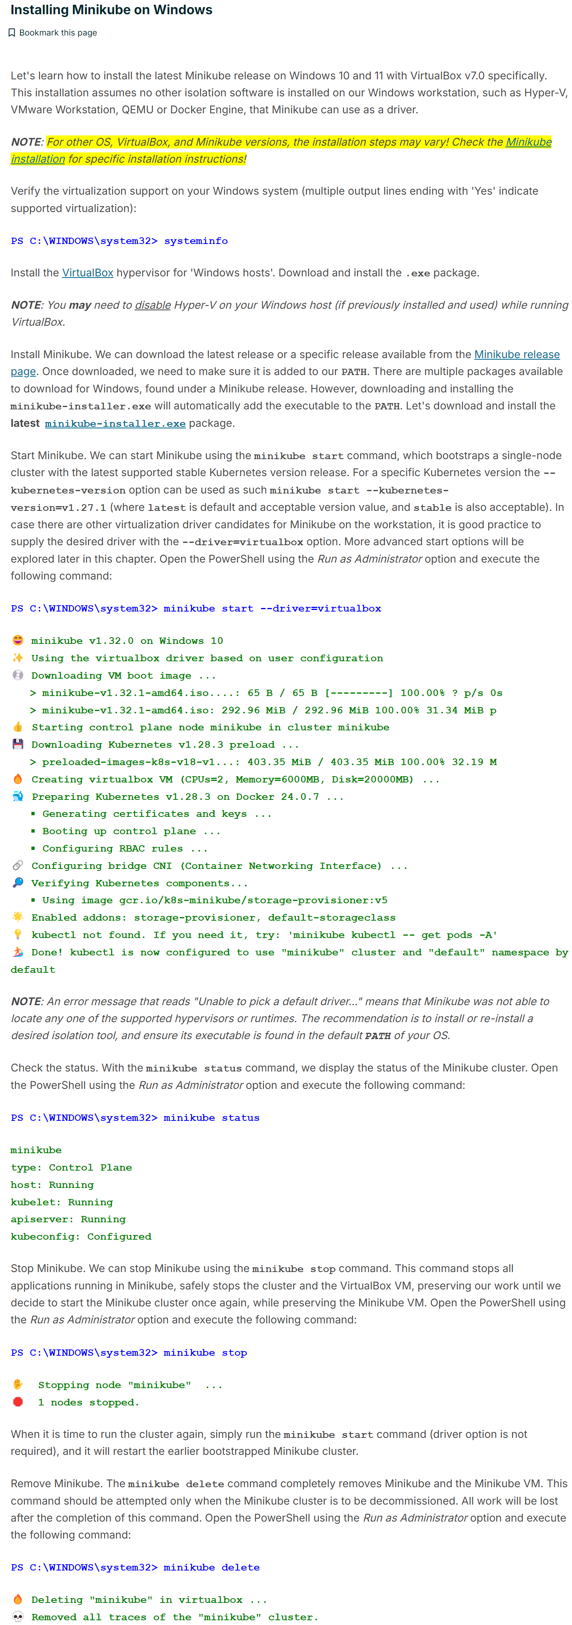





**INSTALLING MINI KUBE ON LINUX**

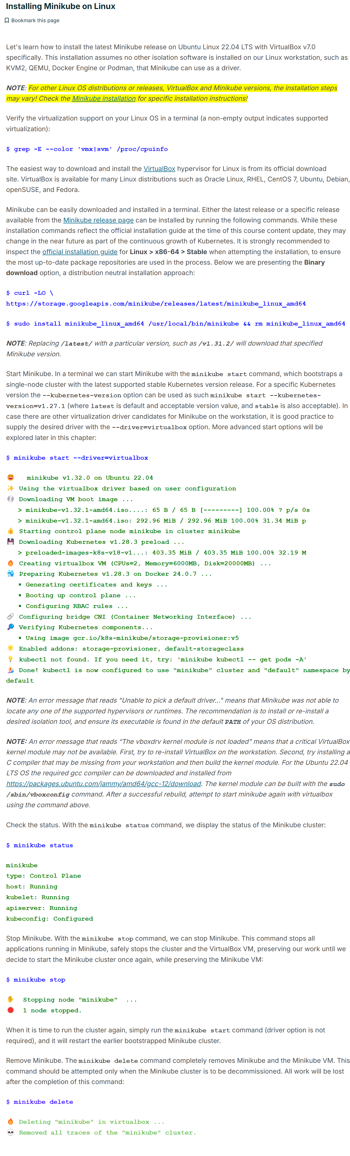





**MINIKUBE ON MAC OS**

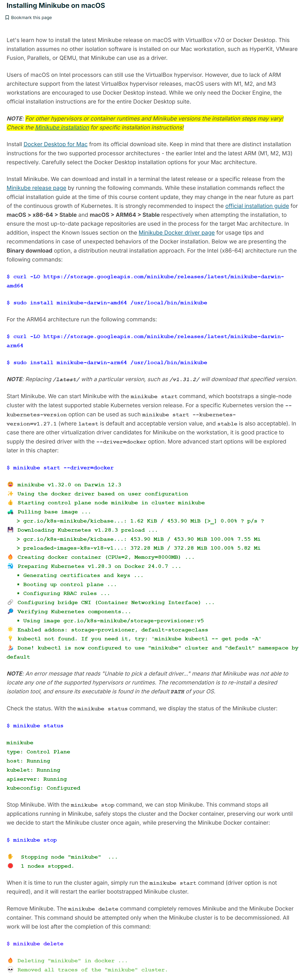





**ADVANCED MINIKUBE FEATURES**

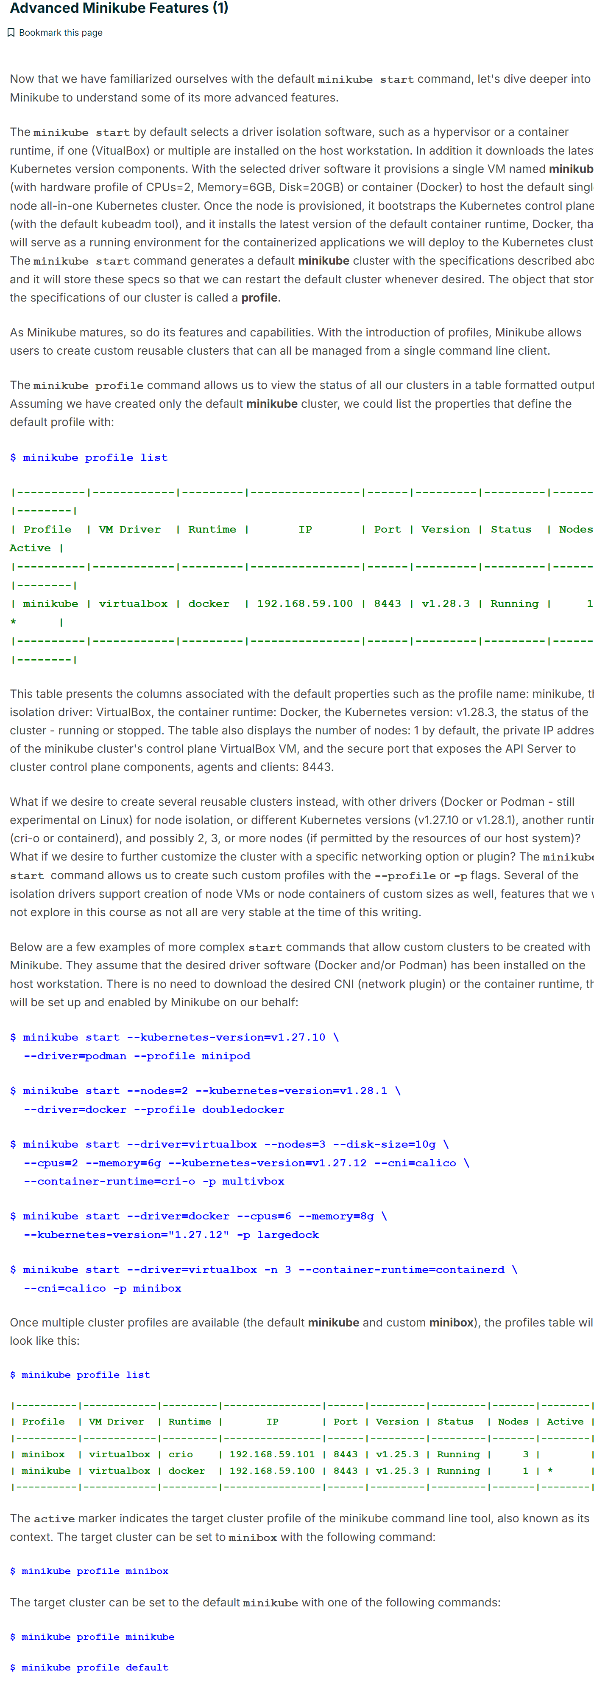



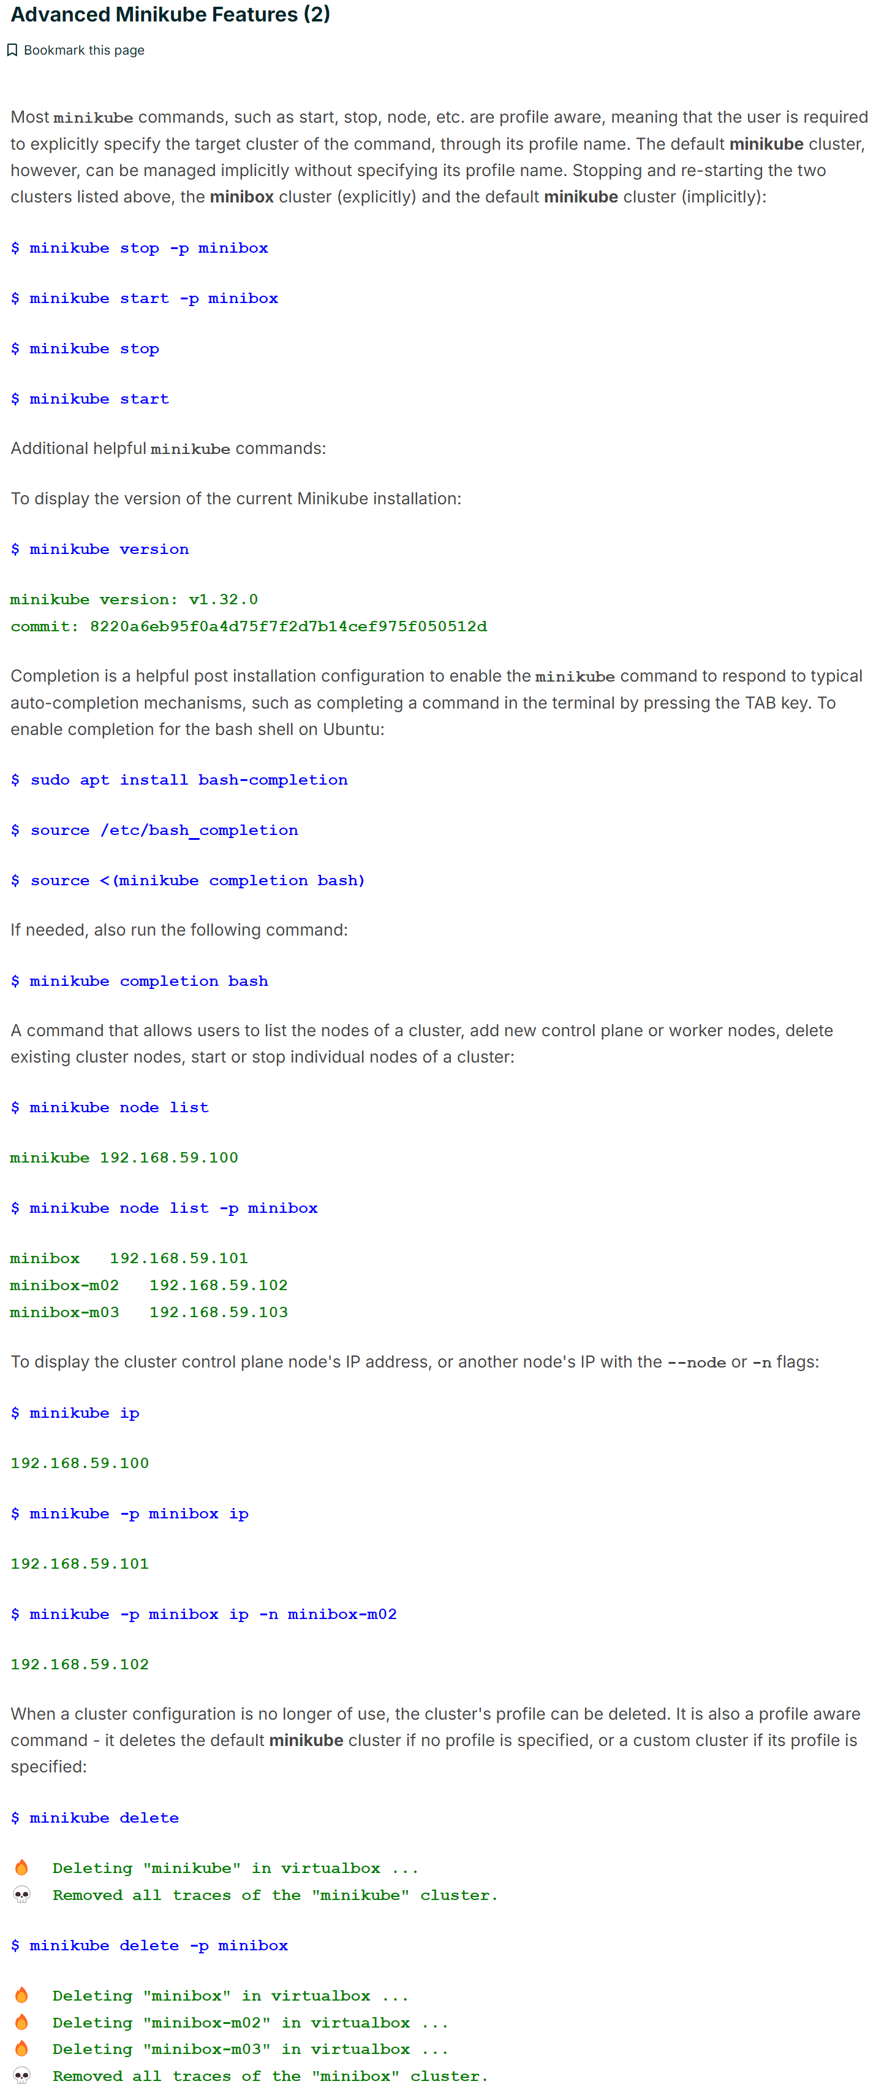



For additional commands and usage options

---🡪 [Minikube command line reference](https://minikube.sigs.k8s.io/docs/commands/).